**Run Method**

1. .Select and Double click on DisplyUserProfile.exe

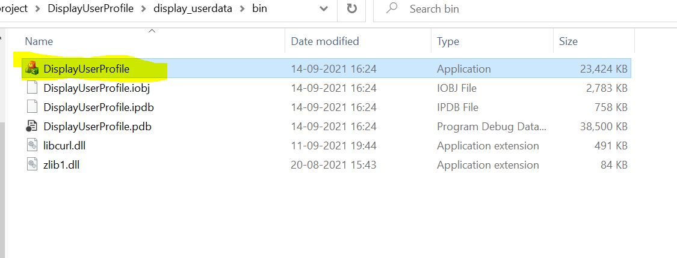

2.select User ID

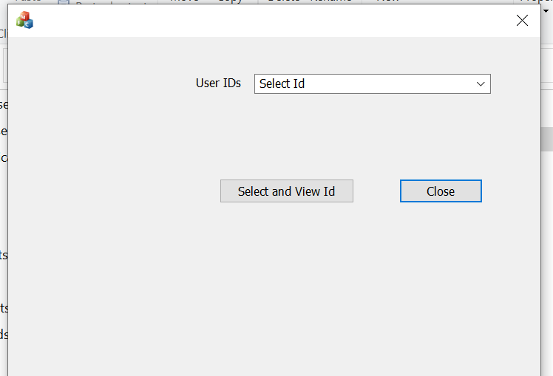

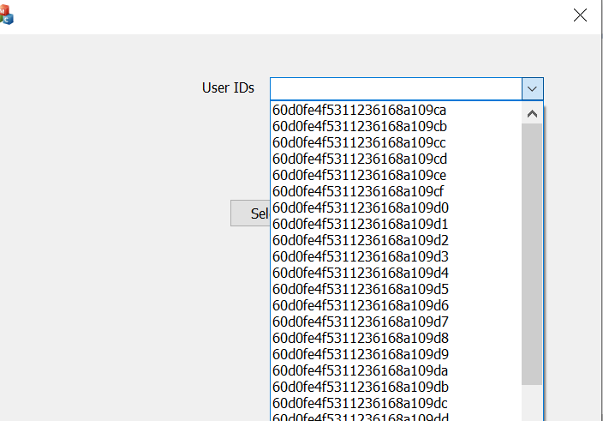

3.After Selecting User Id from DropDown , Click the Select& View Button

4. Finally We got specific user profile as blow screen

